**WEEK - 2 : Advanced SQL (Part 2)**

**Exercise 1: Stored Procedure – GetEmployeesByDept**

**SQL Query:**

-- Create Stored Procedure

CREATE PROCEDURE GetEmployeesByDept

@DeptName VARCHAR(50)

AS

BEGIN

SELECT EmpID, EmpName, Salary

FROM Employees

WHERE Department = @DeptName;

END;

-- Execute Stored Procedure

EXEC GetEmployeesByDept @DeptName = 'IT';

**Output:**

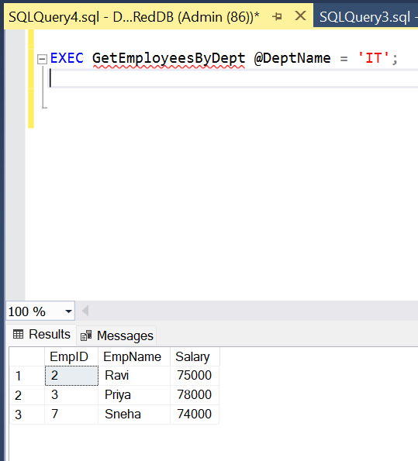

****Exercise 7: Scalar Function – GetBonus****

**SQL Query:**

**-- Create Scalar Function**

**CREATE FUNCTION GetBonus (@Salary INT)**

**RETURNS INT**

**AS**

**BEGIN**

**DECLARE @Bonus INT;**

**SET @Bonus = @Salary * 0.10;**

**RETURN @Bonus;**

**END;**

**-- Use Scalar Function**

**SELECT EmpID, EmpName, Salary, dbo.GetBonus(Salary) AS Bonus**

**FROM Employees;**

**Output:**

